

Final Progress Report

Lathe Automation

M227562 Alex Rubtsov

Contents

Introduction 3

My Contribution 3

Designing the Lathe Logic Board 4

Disassembling of the lathe 4

Final Lathe Version 3 5

Version History of the Lathe 5

Selection of the Ball Screws 6

Conclusion 7

# Abstract

The following report is based on personal contribution to the Lathe Group project that has commenced on the first week of term 1 throughout till the end of the last week of term 4. This report contains research, information notes and so on.

# Introduction

Our primary goal for the project was to automate a ***Colchester Student 1800 Lathe*** that was originally completely mechanical. To complete this we decided that it was best to separate into three different groups and work on individual components rather than working on different things all together. Our groups consisted of Mechanical, Electrical and Control, they all have their own goals and objectives that needed to be completed. Being In the Mechanical Group we were tasked with: Identifying the Ball Screws of the X and Y axis, Identifying the Lathe Components and so on. During the Term 2 of the lathe project we were tasked with the full model of the lathe be completed along with all of the components be ordered and completed hence we weren’t able to fully automate our lathe due to the multiple projects occurring in the FabLab.

# My Contribution

My Contribution to the mechanical team consisted of:

* NSK Balls Screws What are they?
* Tool Post Carriage CAD Drawing
* Tool Post Holders CAD Drawing
* Slightly Organizing our Mechanical Group.
* Designing the Lathe Logic Board
* Putting together the Final Version 3 of the Lathe / Fixing any problems / adding changes
* Disassembling of the Lathe
* Adding Version History of the Lathes in photographic form
* Selection of the Ball Screw
* Lathe Cover Progress
* Lathe Cover Rails and Carriage
* Gearbox Handle and Block offs
* Ballscrew nut modification

## NSK Ball Screws, What are they?

I’ve done some small research / information on how ball screws are and how they work. Their Function and their design.

*A Ball Screw is a mechanical linear actuator that translates rotation motion into a linear motion. To put it into perspective it’s essentially a rod that moves within a thread that spins and due to this rotational movement it can either move forward or backwards. With this in mind it’s important to note that due to this design there is very little friction due to the use of ball bearings hence the name Ball Screws. Due to this ball bearing design the tolerances are very little and can achieve situations that require very high precision. It is also an enclosed system that is self-lubricated, however needs to be serviced once in a while.*

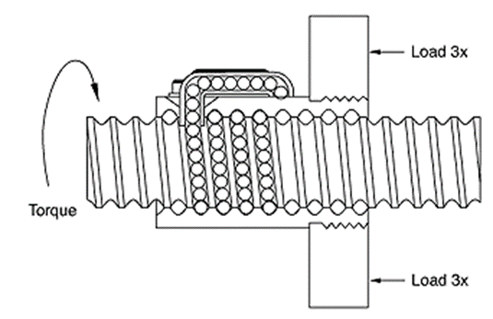

I’ve also included some of the equations that can be used to calculate the following:

*T= Torque applied to Screw or Nut*

*F= Linear Force Applied*

*l= Ball Screw Lead*

*v= Ball Screw Efficiency*

## Organizing Mechanical Group

I have contributed by helping both of my team members in doing work while also organizing them to their own specific things. This includes a small list of things that we wanted to accomplish Rosani and Sean being part of my group I helped them out with any enquires that they had.

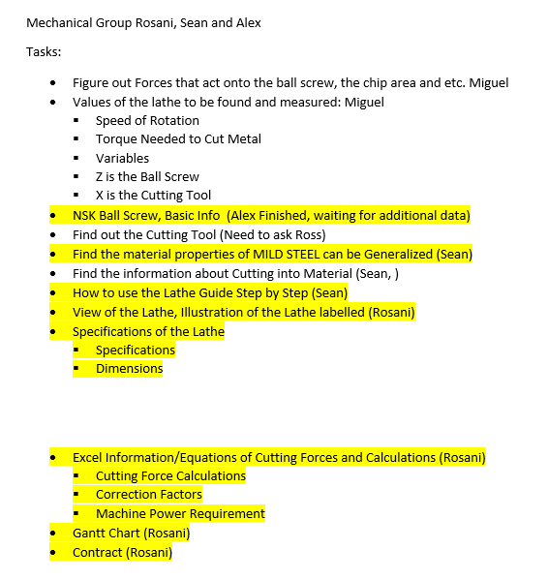

While having a small list I believe that I have contributed to this task and managed to organize our group accordingly.

## Tool Post Top Carriage CAD

The Tool Post consisted of multiple of different parts that were integrated into one. I’ve separated these drawings and drew them separately.

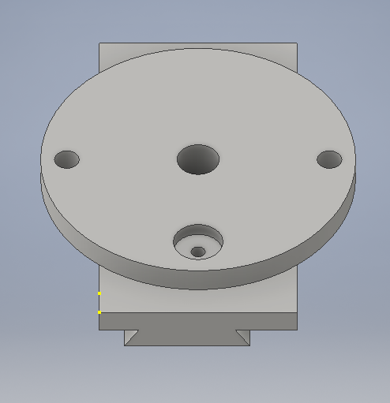Here is what they looked like:

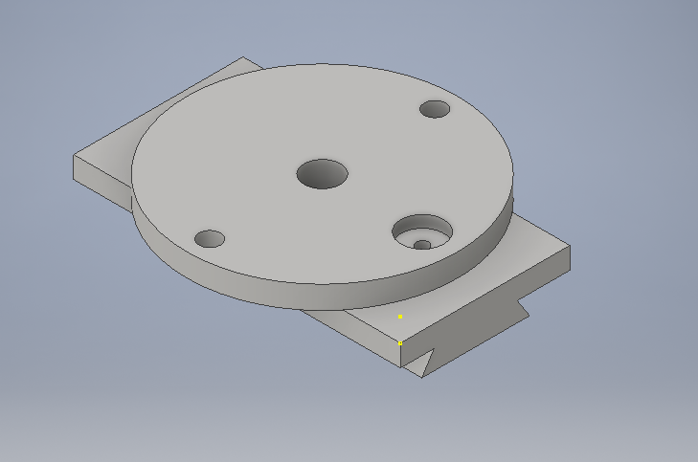

One of the biggest challenges with this particular drawing was figuring out the small little bits like measuring inside diameters that cannot be accused by a normal ruler or a Vernier because of the uneasy access. Also relating different measurements to their counter parts. Having this tool bit into two parts which made things a little easier.

## Tool Post Bottom Carriage CAD

This particular drawing wasn’t as hard to do but it still had its complications. For example this particular Tool Holder had a mechanism that I wasn’t able to replicate. Hence it just has a parts that’s not 100% functional.

Here is what it looks like:

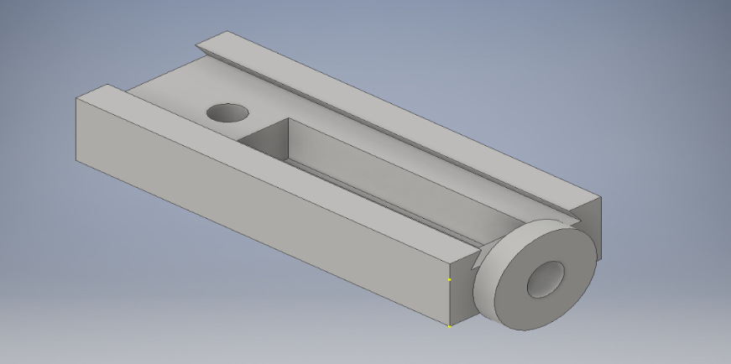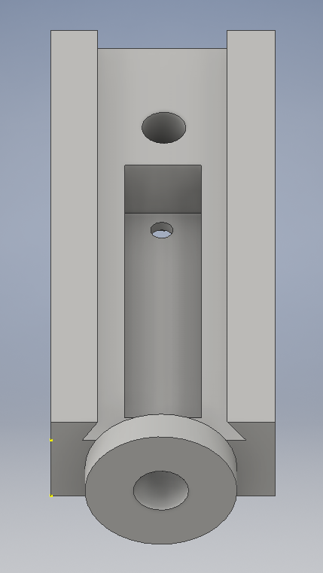

## Designing the Lathe Logic Board

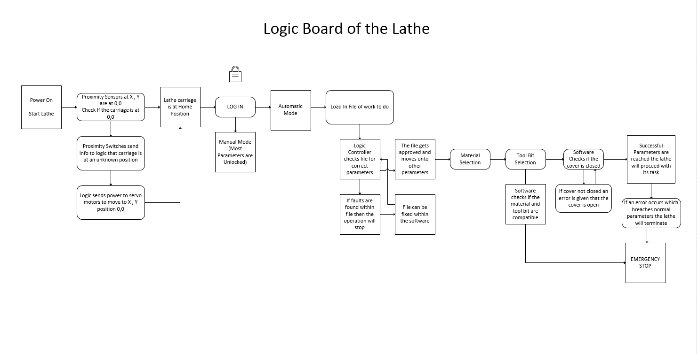This particular task was assigned by John Vivian to complete a rough copy of the lathe “Logic Board”. A logic board is how our lathe will run on the computer that means that there will be certain parameters that the lathe will have to follow. For example the lathe will always try and find its home position if it loses its position.

## Disassembling of the lathe

Nimesh and I were disassembling the gear box of the lathe, Ross told us to take off only certain parts and gears, there weren’t too many things to take off but it did take us almost two sessions to do so. Many of the challenges that we were faced with was the small and tight spaces to take off the C-clips.

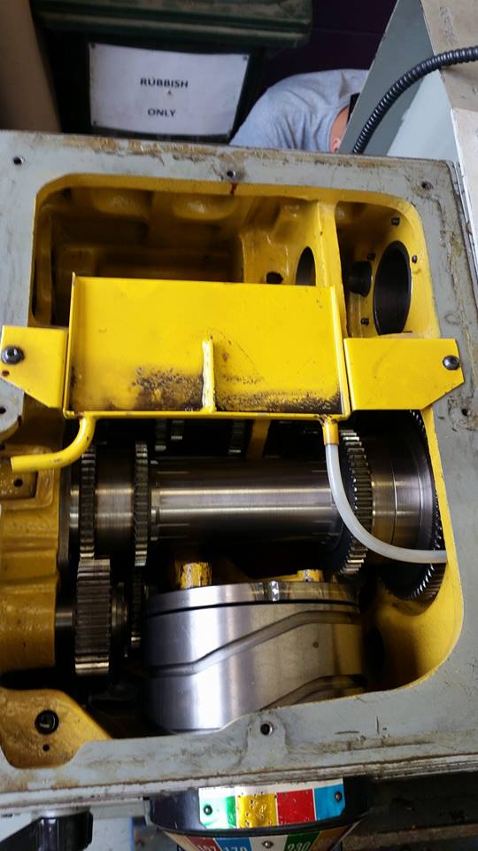 (Before) (After)

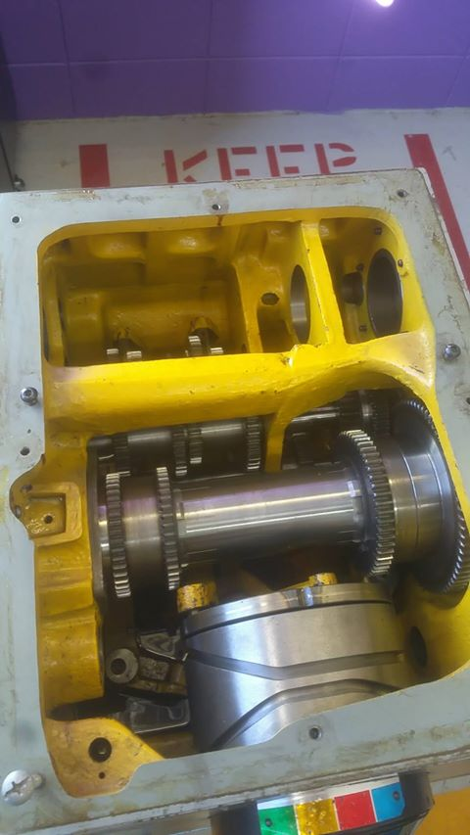

## Final Lathe Version 3

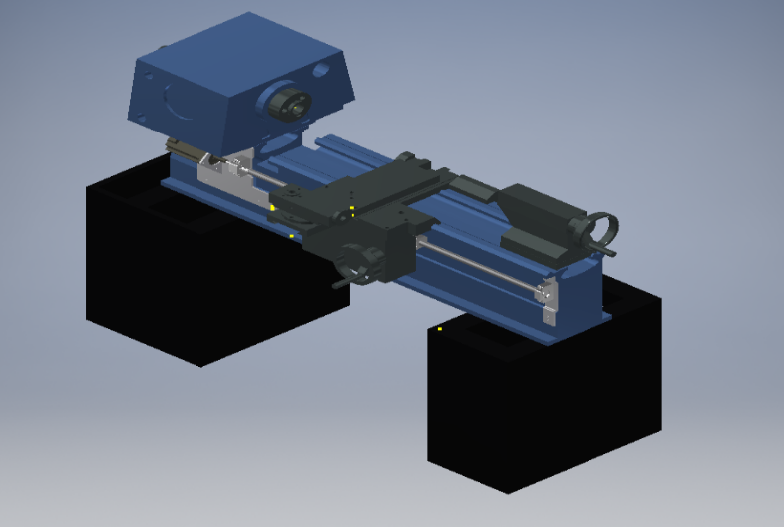Closer to the end of the semester 1 I was tasked with getting all of the updated parts and putting them into our final version of the lathe. This was a fairly easy process as the lathe was already assembled and all I had to do was update some parts and insert some new parts. This is what the lathe looks like in Version 3.

## Version History of the Lathe

This was a pretty simple task, I’ve filtered through our models and took screen shots of the models and divided them into three versions.

Version 1 Version 2

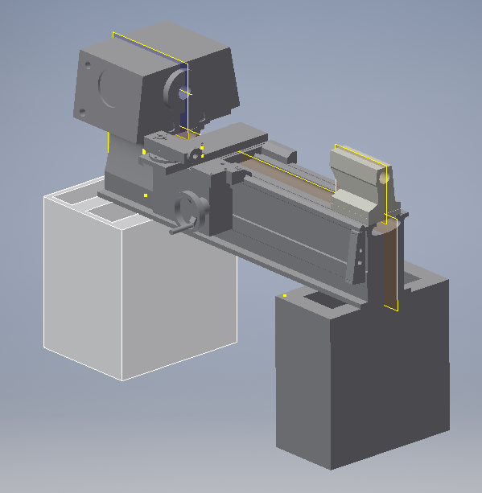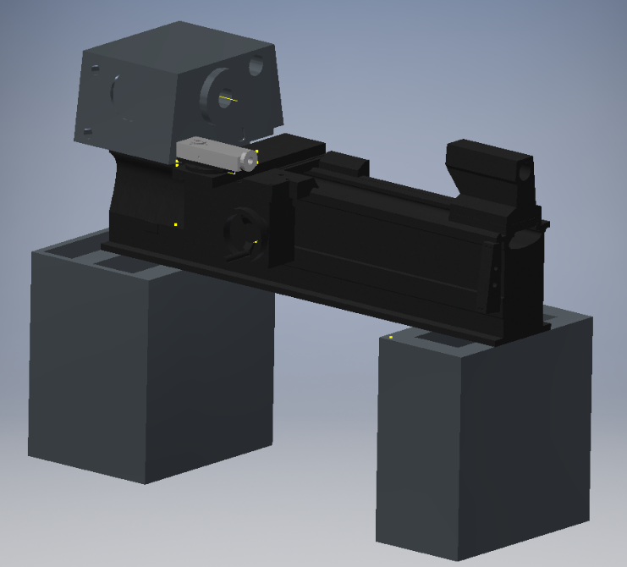

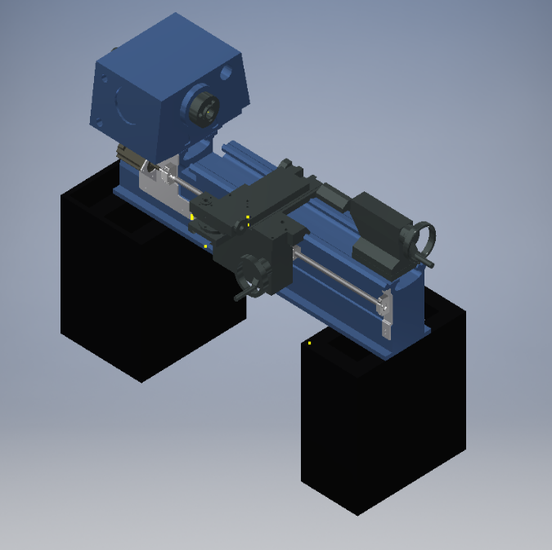 Version 3

## Selection of the Ball Screws

At the start of the project we split into mechanical groups and I was tasked with finding a ball screw that was appropriate for our lathe, I was told to find a ball screw along with the housing the ball screw will sit in. There were two different ball screws one was the long ball screw and one was short. The THK website provided us with 3D CAD drawings of the ball screws and the housings as well. However my selection of the ball screw was passed onto Miguel which did the selection of all the 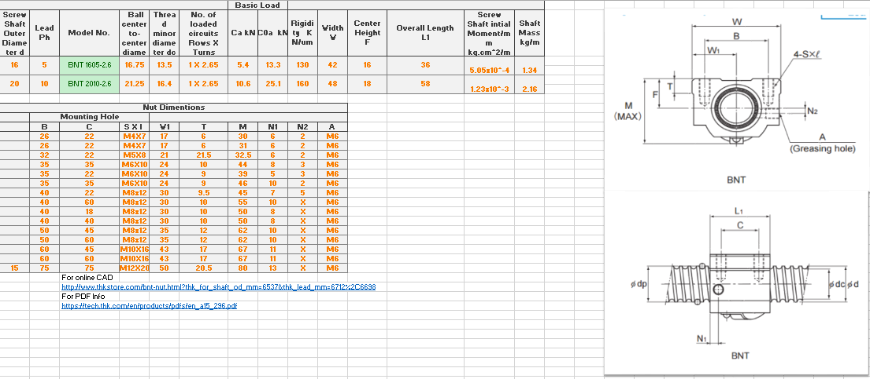ball screws. I’ve also created an excel sheet which showed different info on the ball screws.

## Lathe Cover and Various parts with it

While working on the project I decided to help one of my team members with the design of the lathe cover. Along with the rails and the wheel tracks.

### C:\Users\M227562\Documents\Arexu san\Pics\Lathe Cover Dimentions.PNGLathe Cover Door:

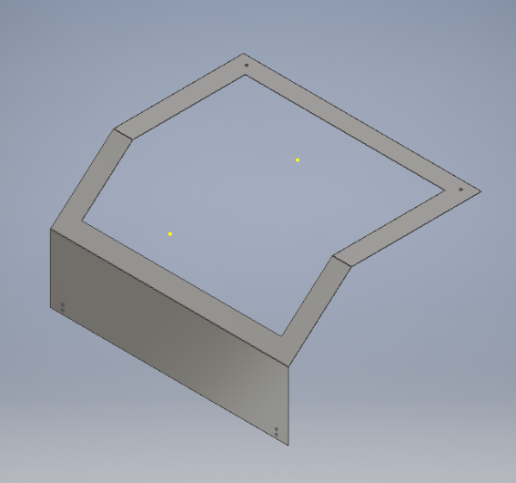

## Lathe Wheel Tracks

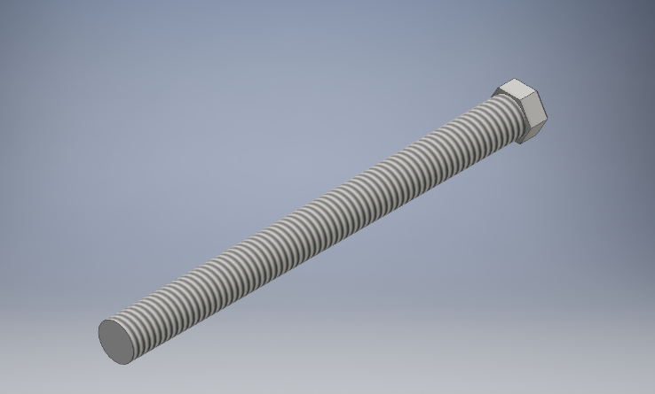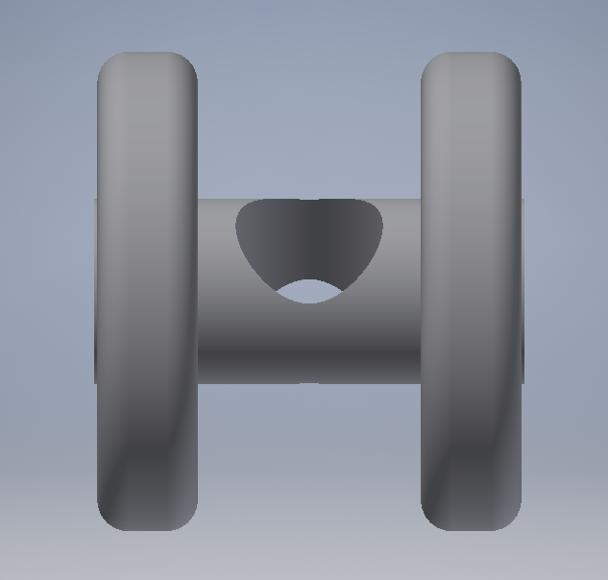These are the wheels that I’ve designed from the standards that were given to me by my research.

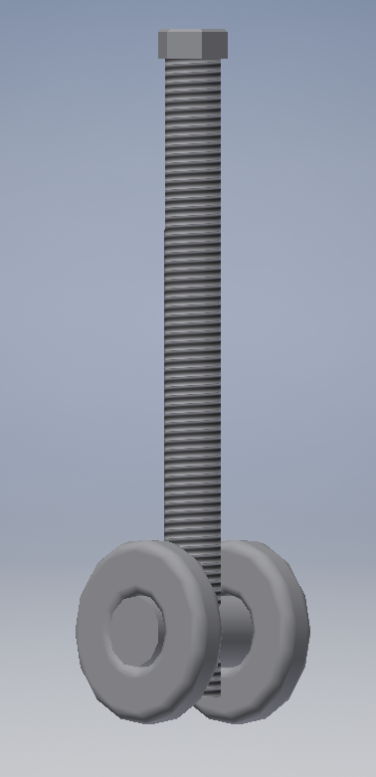

## Lathe Rails for the Tracks

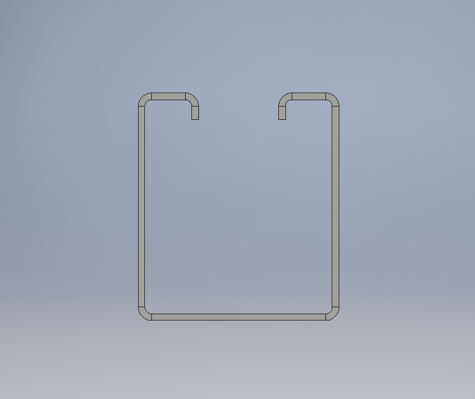These Rails were made to the standard to fit the wheel track.

## Folded Door with the Wheels attached

Folded door with all the tracks and a simple L shaped bracket.

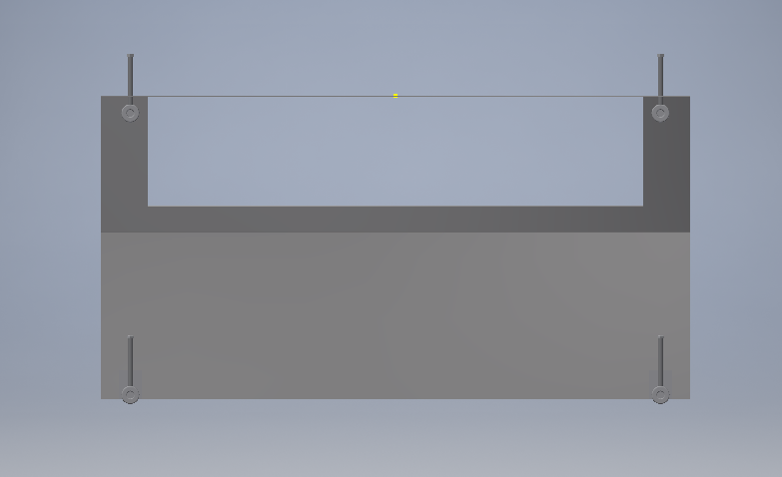

## Gearbox Handle

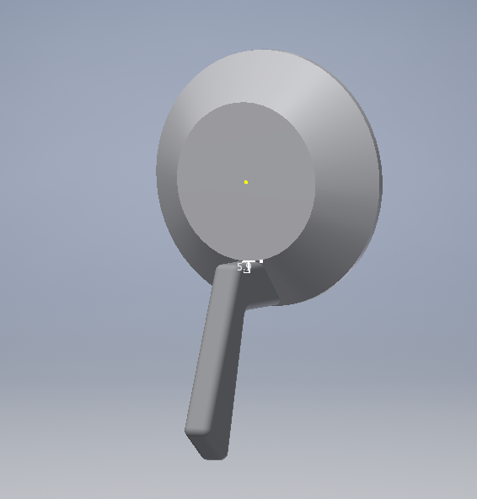A drawn gearbox handle.

## Ball Screw Nut Unmodified

Ball Screw that we have received that we had to modify to fit into the appropriate place.

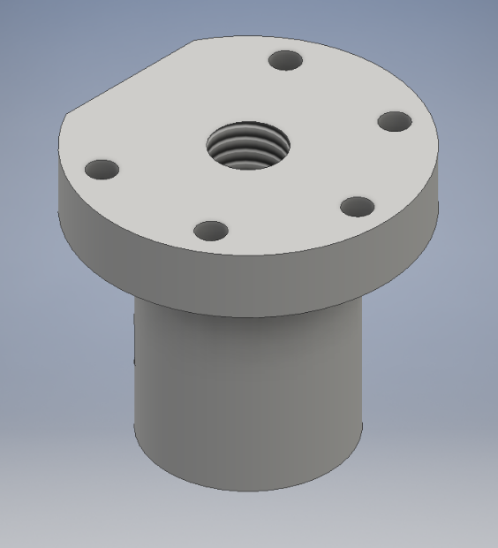

# Conclusion

We have completely finished the 3D aspect of all of the lathe and the whole design. Unfortunately due to having multiple people working on different parts of the lathe it meant that we needed to get all of the 3 to 4 different groups to combine into one file. However due to the inventor constrains they all get deleted once they go into a new model which would take a lot of time and effort which we did not have. However all of the major automation of the lathe actually were purchased and sorted out. All that needs to be done is the actual modifications and some tidying up and the lathe would be mechanically finished. Not talking about the Automation due to the fact that we haven’t gotten that far into the project. This is something for the next group or the lectures to continue working on.

Over all I think that as a group we’ve done quite well. Due to not having lectures in class has greatly affected our project and our ability to do anything project related.

## Recommendations

I think that it’s important to have all of the drawings of the parts to be draw to 101% accuracy and as quickly as possible which negates further modification to the drawings. Along with communication with the lectures.